**Charlie Group**

Chad Hendren – Tatiyana Dean – Vincent Sarlo

12/8/2021

CSD 310 Assignment 11.1

**Case Study Context for Willson Financial:**

*While Jake and Ned know that the customer list has grown in the past year, they’ve been so busy that they decided it was time to step back, take a look at the client list, their assets, and the billing process to make sure the customers were getting the best service possible, while keeping the business in the black. One decision to make is whether to change the billing structure. Some of the questions to be answered are: How many clients have been added for each of the past six months? What is the average amount of assets (in currency) for the entire client list? How many clients have a high number (more than 10 a month) of transactions?*

The following report output contains “Total Transactions from Accounts in the Past Month,” “Clients Who Had Over 10 Transactions from Accounts in the Past Month,” and “Number of Clients Who Have Made Over 10 Transactions In The Past Month.”

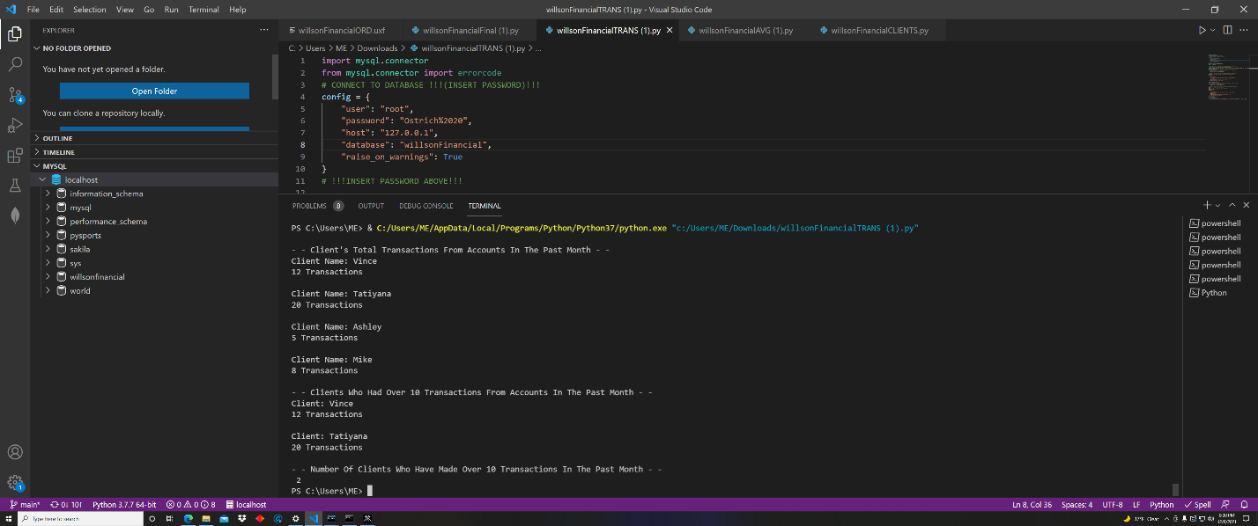

The next screenshot contains output containing “Amount of Assets from Clients,” “Sum of All Clients’ Assets,” and “Average of All Assets.”

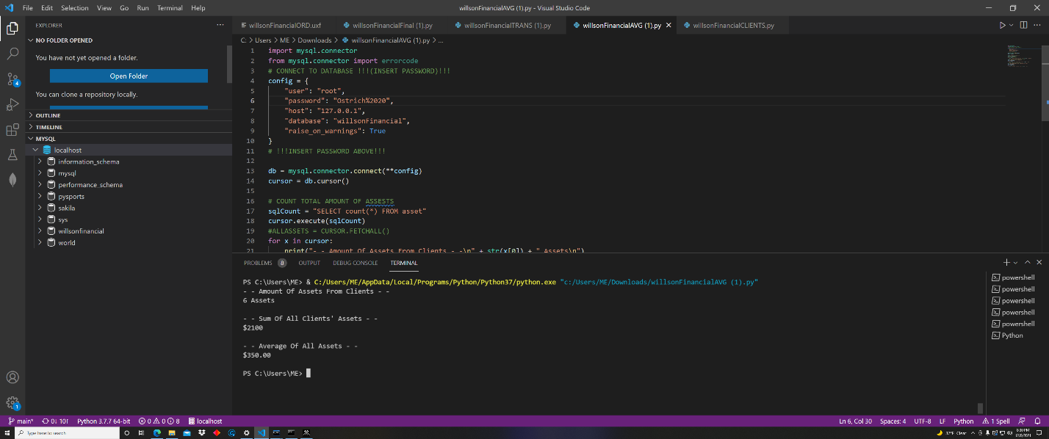

Finally, the third screenshot shows the output for “Number of Clients Who Have Joined in the Last 6 Months,” from two perspectives: Client Name + Date Joined and total number of clients joined in each of the months in the 6 month range:

